

# AUGUST- 2023

**Programme : B.E / B. Tech**

**Course Code : CSA1190**

**Course Name** **: OBJECT ORIENTED ANALYSIS AND DESIGN**

**Date : 25-08-2023**

OOAD PRATICAL DAY 1 Marks:20

***DAY-1***

***1.AIM:-***To implement UML diagrams for passport management system..

DESIGN:-

***1.USE CASE:***

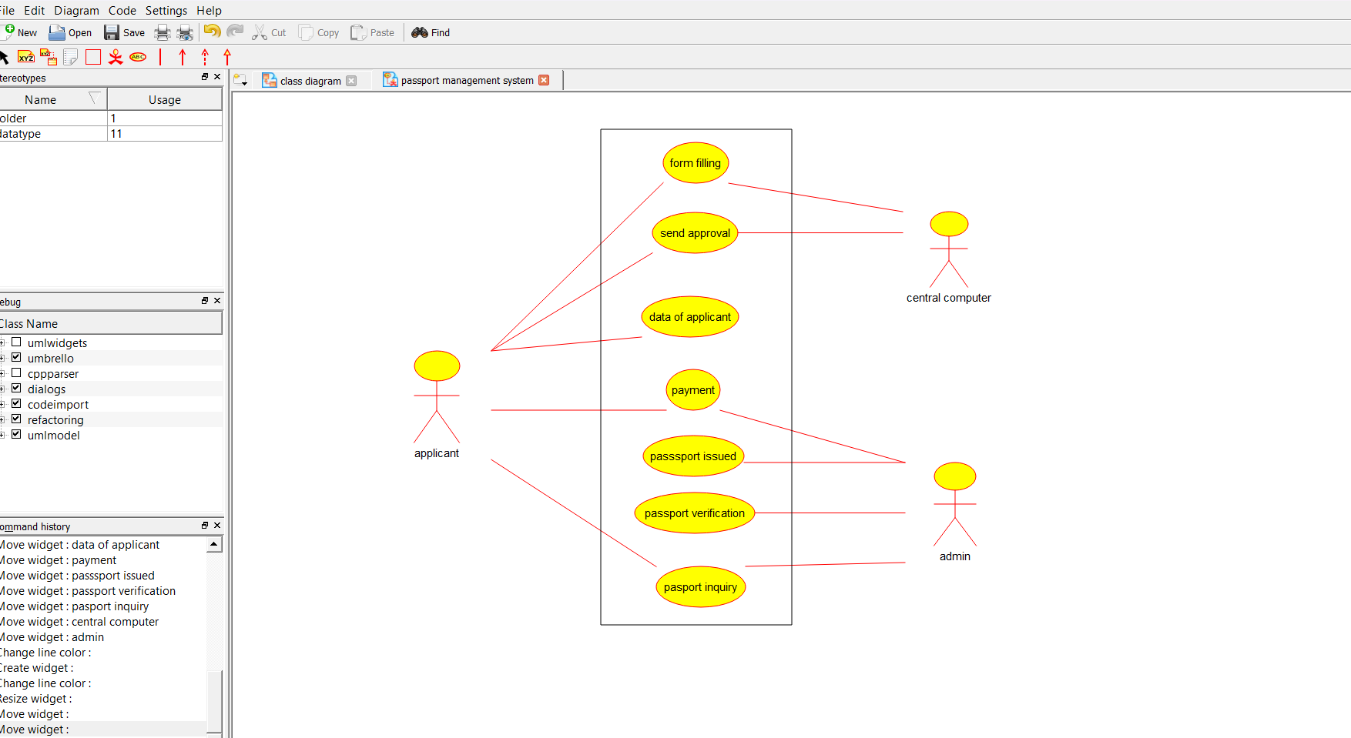

***2.CLASS DIAGRAM:-***

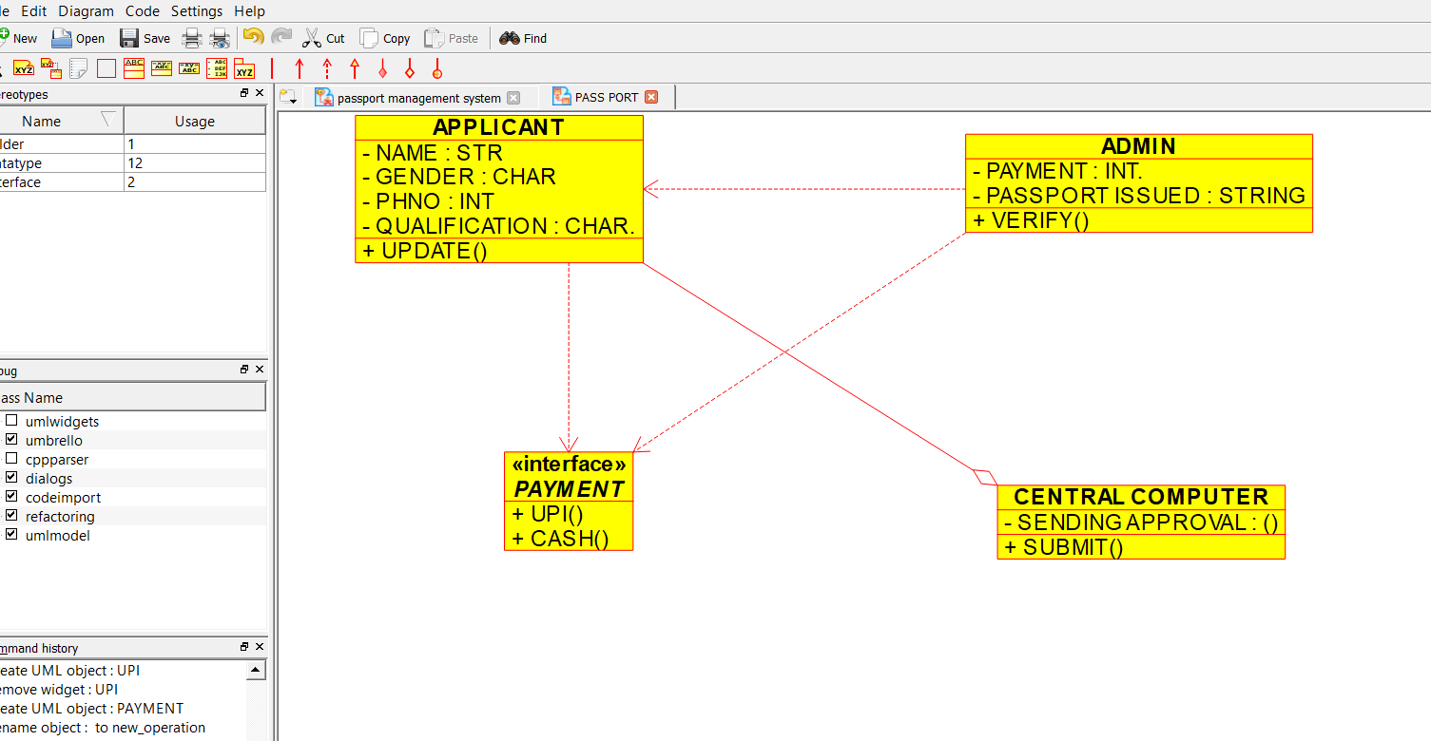

***SEQUENCE DIAGRAM:-***

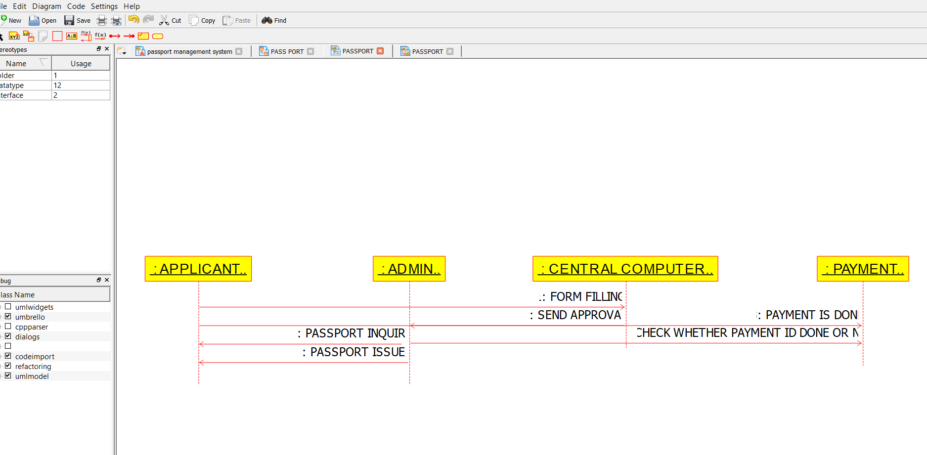

***PACKAGE DIAGRAM:-***

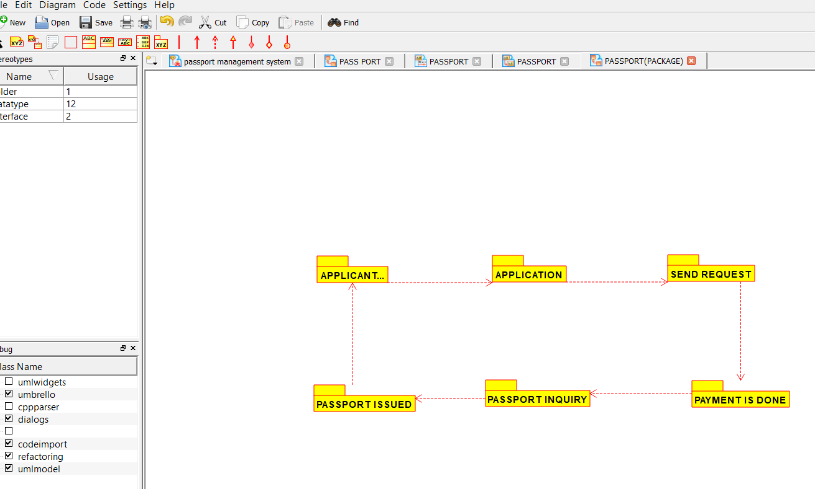

***Experiment: Bank Book Process***

***2.AIM:-***To implement UML diagrams for BANK BOOK PROCESS ..

DESIGN:-

1.USE CASE:

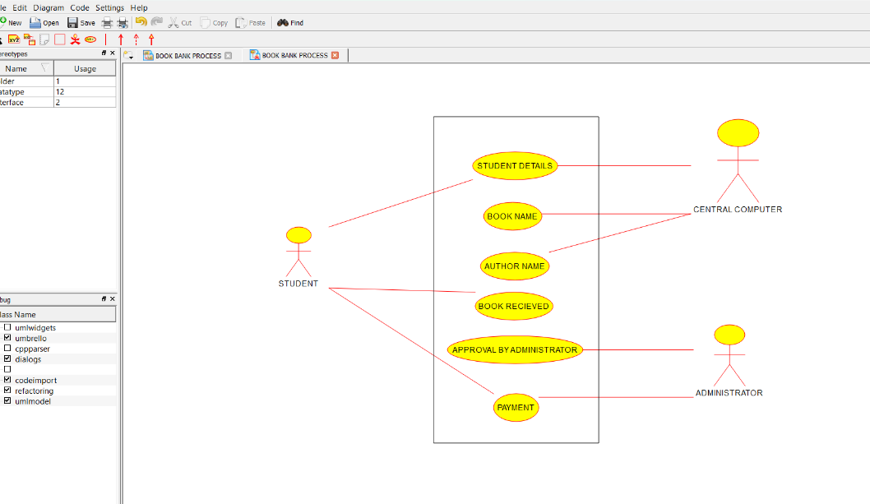

***2.COLLABORATION DIAGRAM:-***

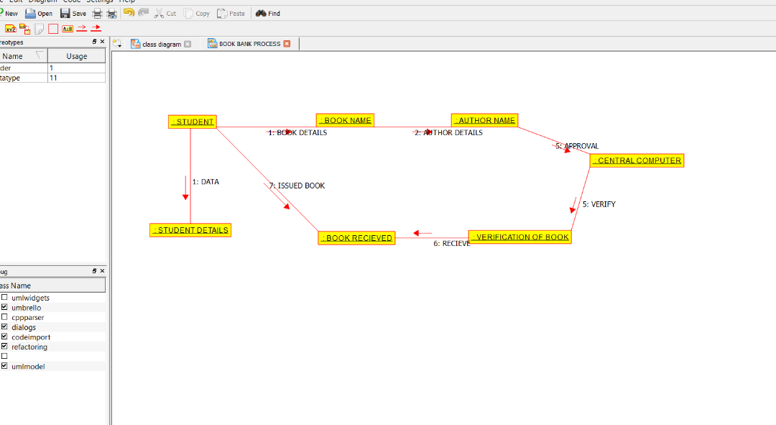

***3.DEPLOYMENT DIAGRAM:-***

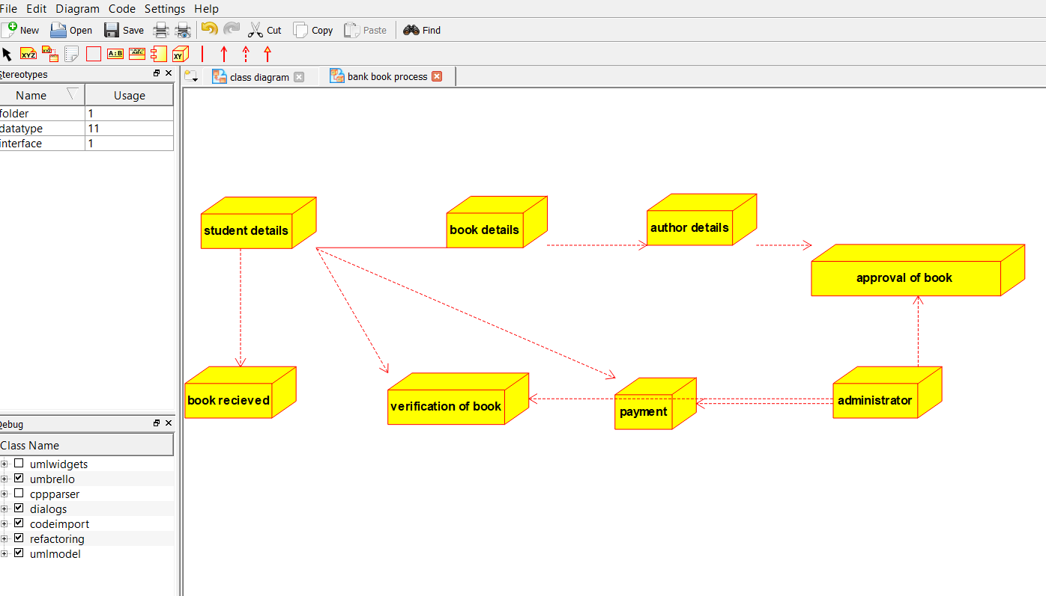

***3.AIM:-***To implement UML diagrams for EXAM REGISTRATION PORTAL…

**DESIGN:-**

***1.COMPONENT DIAGRAM:***

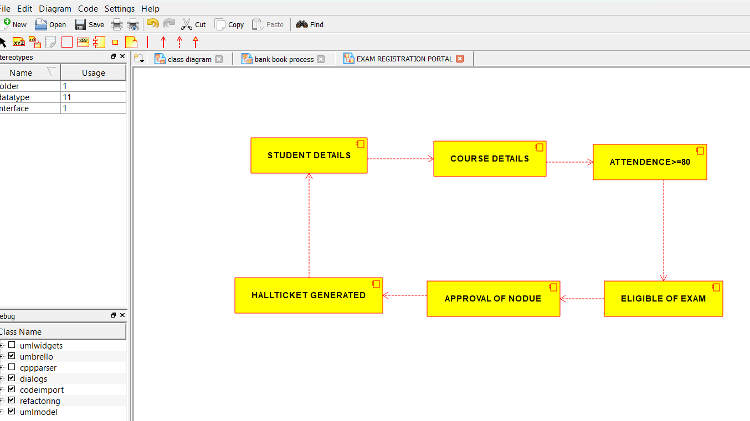

***2.PACKAGE DIAGRAM:-***

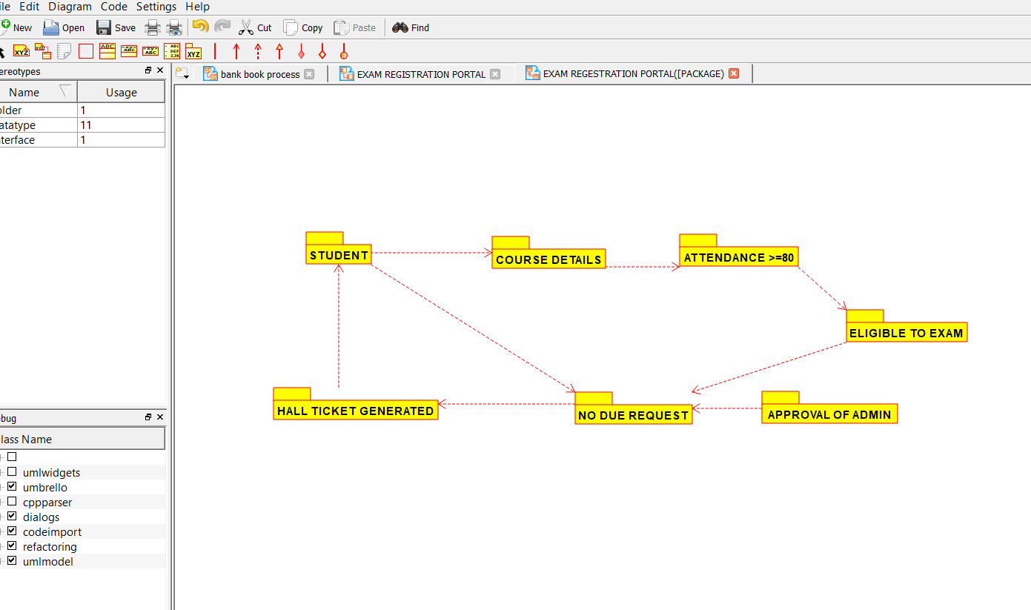

3.USECASE DIAGRAM:-

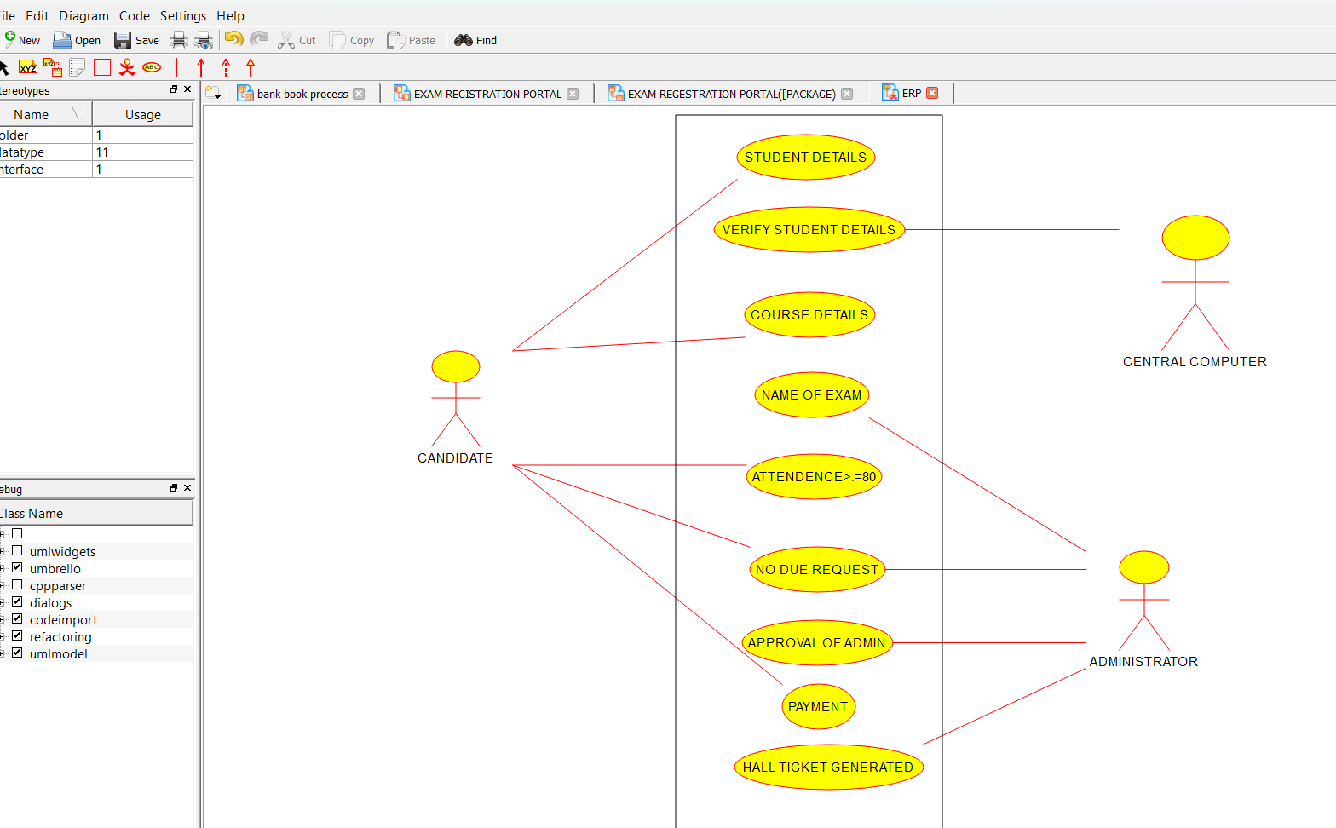

***4.AIM:-***To implement UML diagrams for STOCK MAINTAINANCE SYSTEM…

***DESIGN:-***

***1.STATECHART DIAGRAM:-***

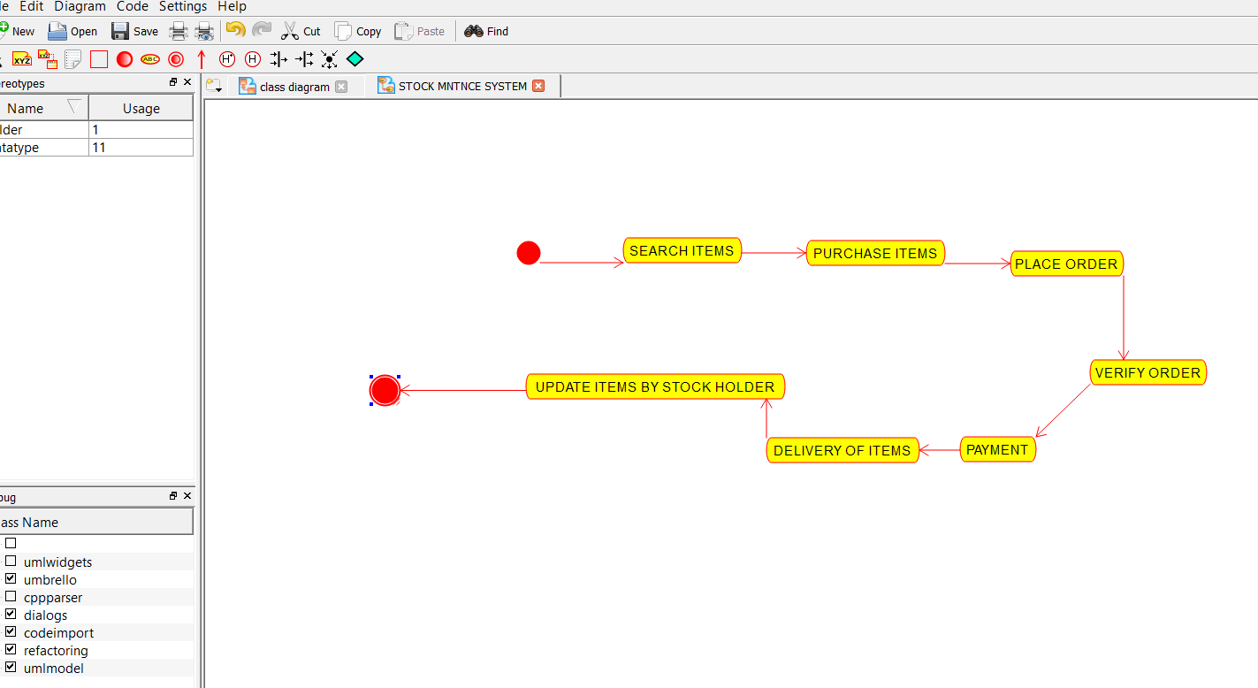

***2.DEPLOYMENT DIAGRAM:-***

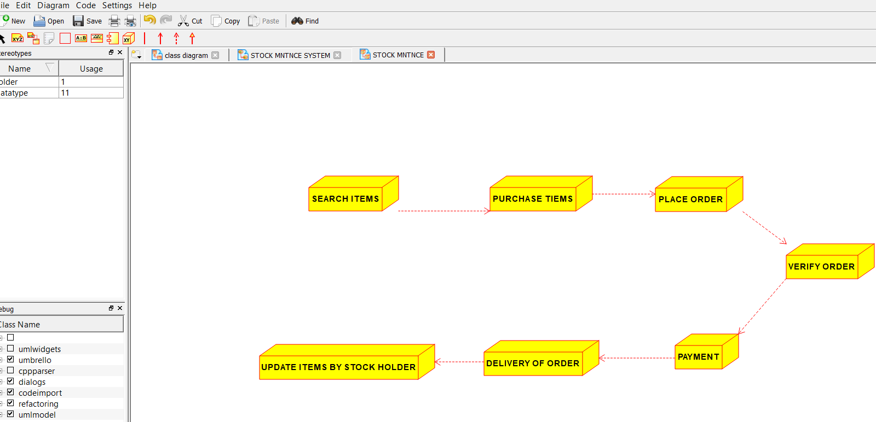

***3.PACKAGE DIAGRAM:-***

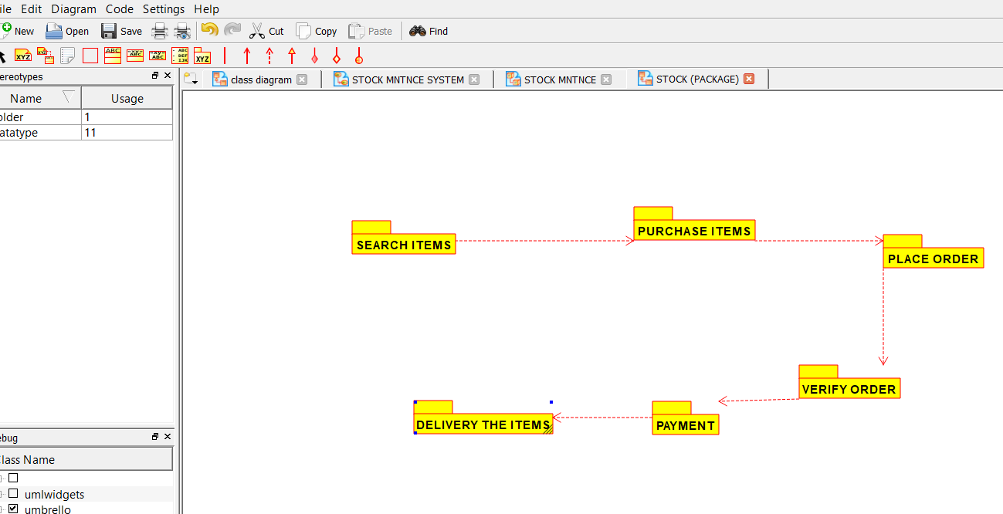

***5.AIM:-***To implement UML diagrams for ONLINE COURSE RESERVATION SYSTEM…

***DESIGN:-***

***1.COLLABORATION DIAGRAM:-***

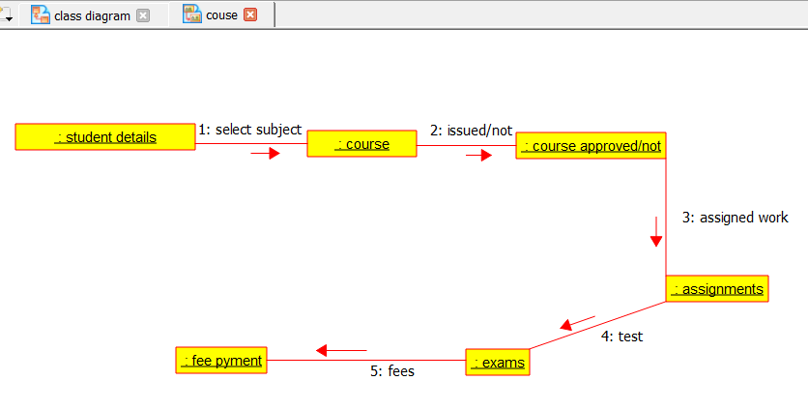

***2.USECASE DIAGRAM:-***

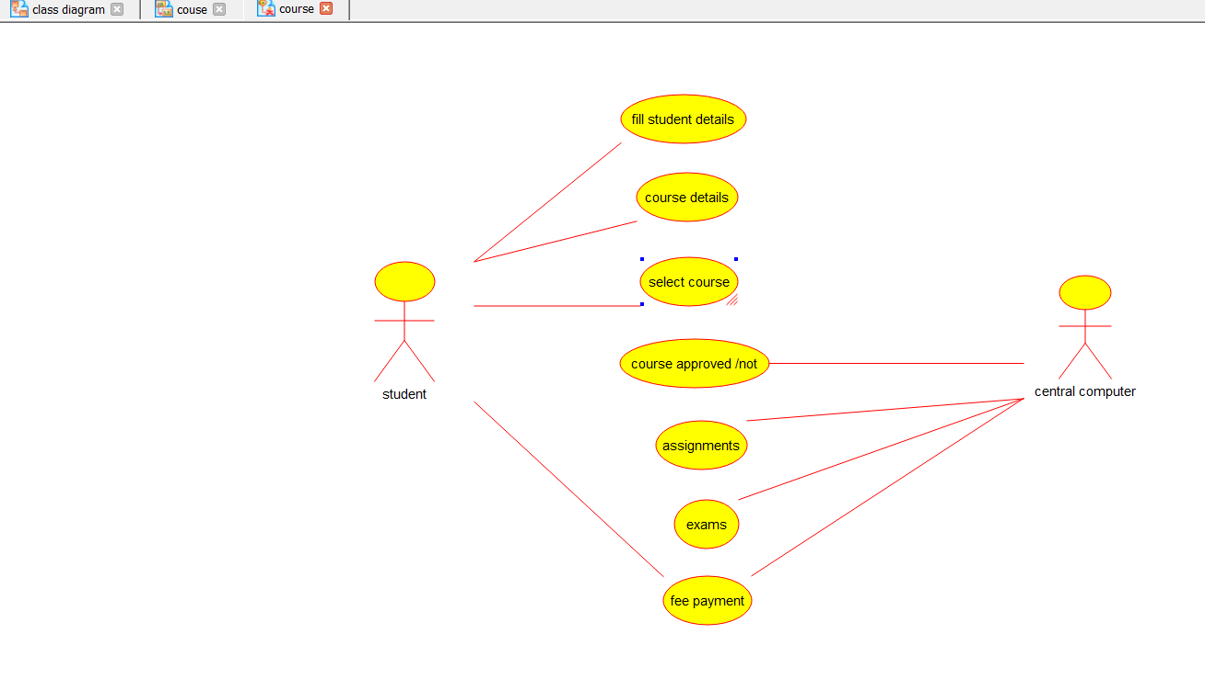

***6.AIM:-***To implement UML diagrams for E-TICKETING SYSTEM…

***DESIGN:-***

***1.ACTIVITY DIAGRAM:-***

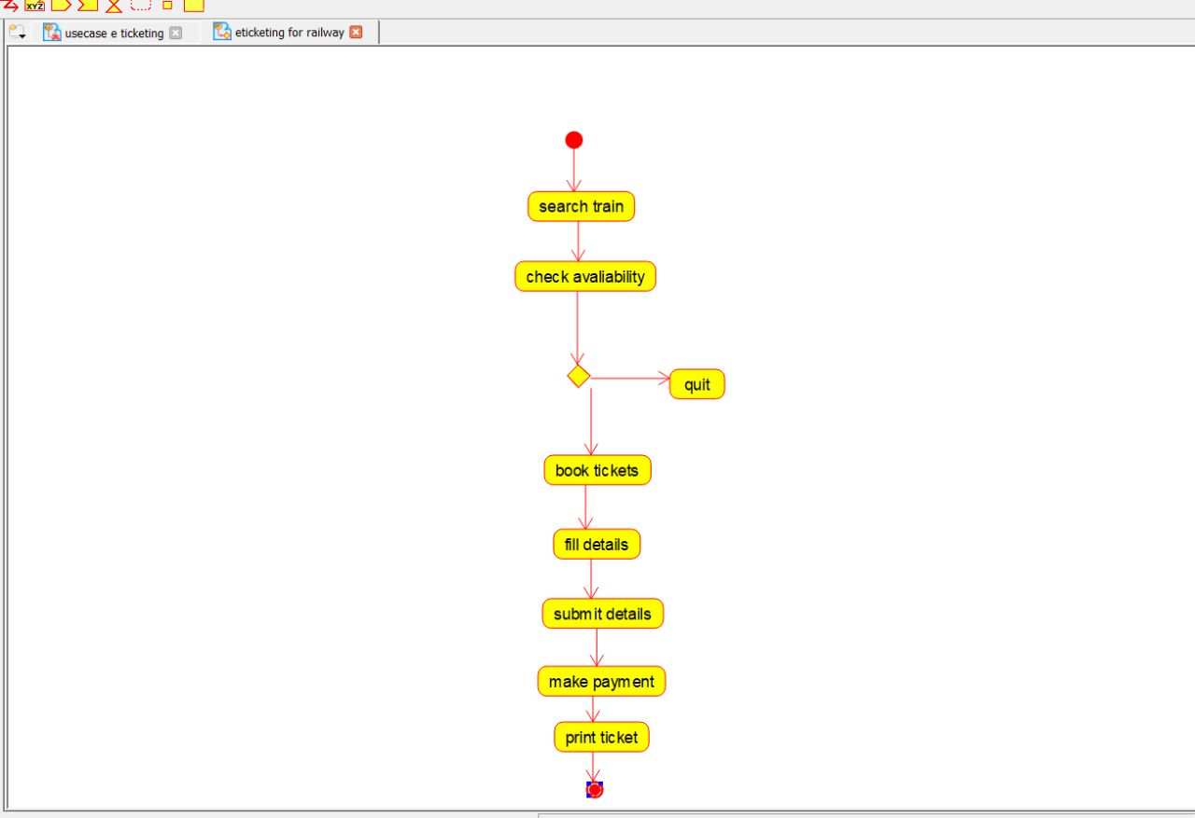

2.USECASE DIAGRAM:-

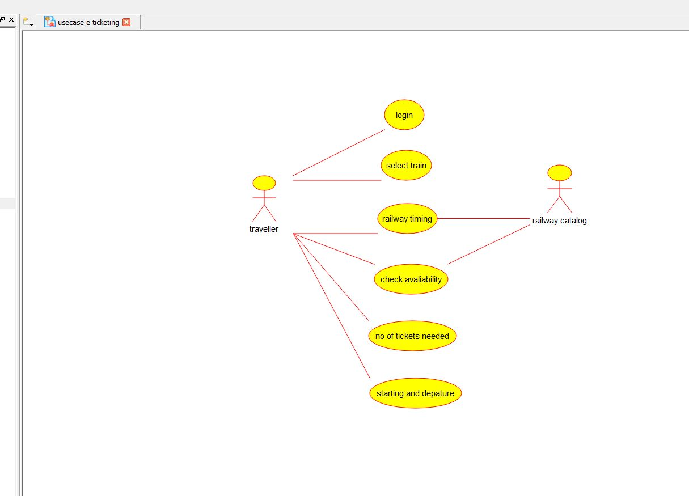

***3.COMPONENT DIAGRAM:-***

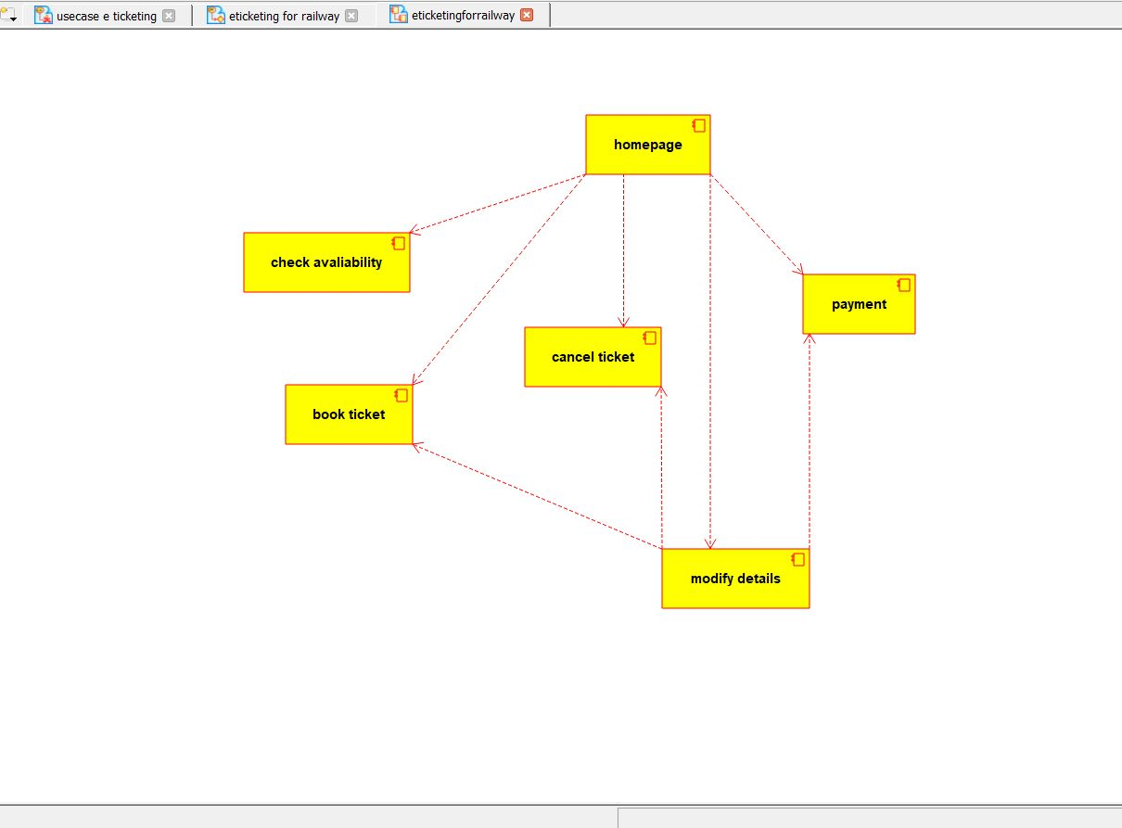

***7.AIM:-***To implement UML diagrams for CREDIT CARD PROCESSING SYSTEM…

***DESIGN:-***

1.ACTIVITY DIAGRAM:-

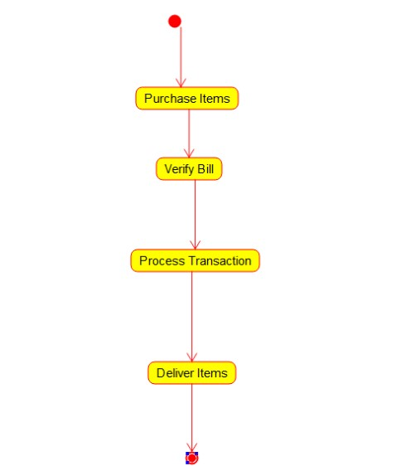

2.CLASS DIAGRAM:-

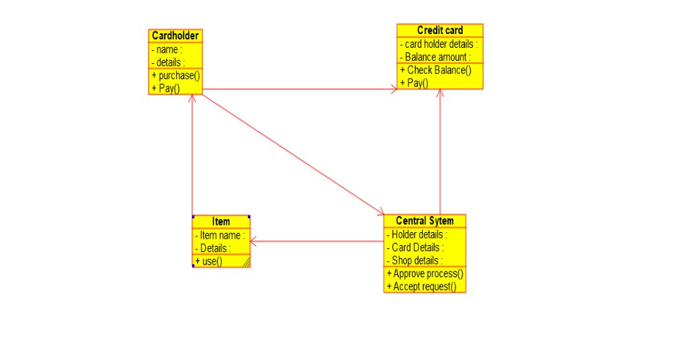

3.COMPONENT DIAGRAM:-

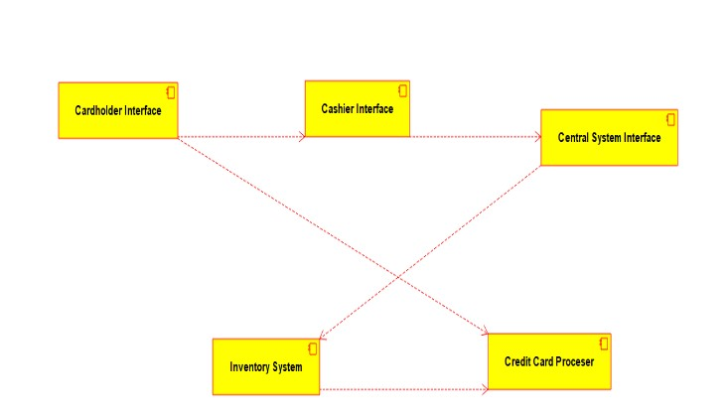

**8.AIM:-**To implement UML diagrams for Software Personnel Management SYSTEM…

***DESIGN:-***

1.COLLABORATION DIAGRAM:-

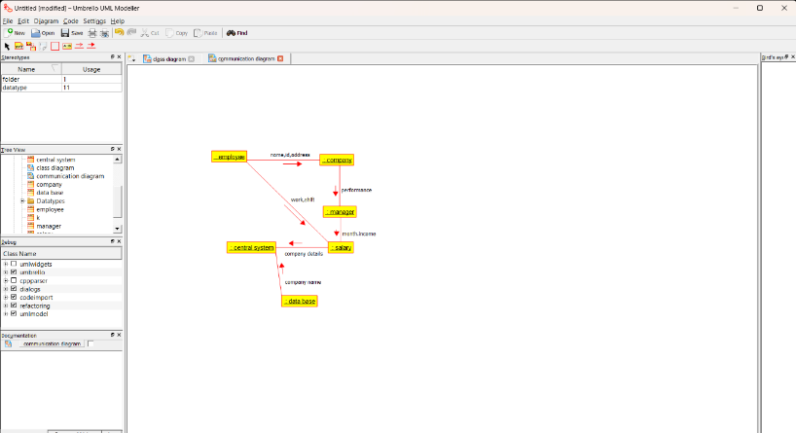

2.COMPONENT DIAGRAM:-

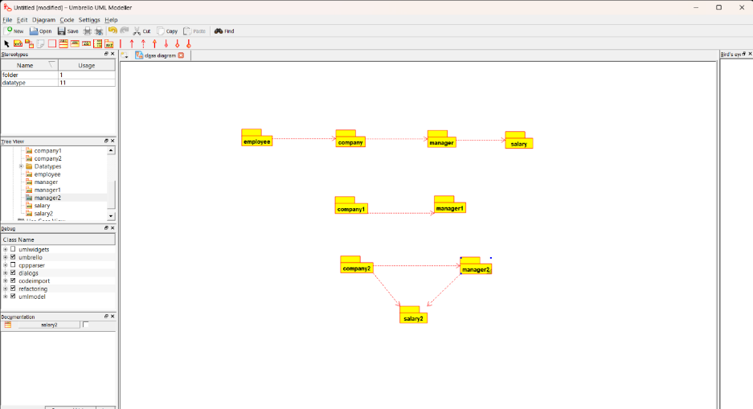

3.USECASE DIAGRAM:-

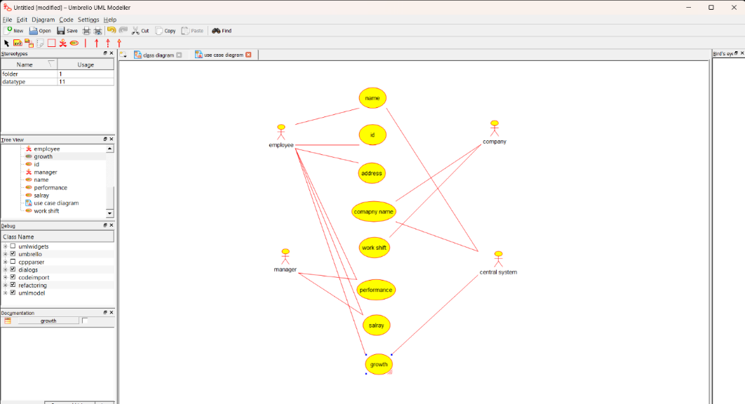

***9.AIM:-***To implement UML diagrams for E-BOOK MANAGEMENT SYSTEM…

***DESIGN:-***

1.USECASE DIAGRAM:-

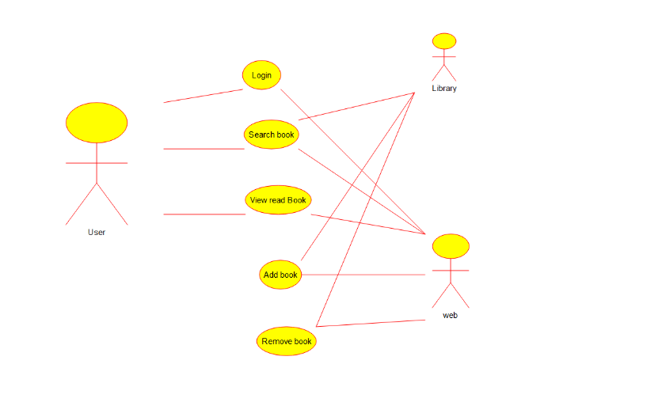

2.CLASS DIAGRAM:-

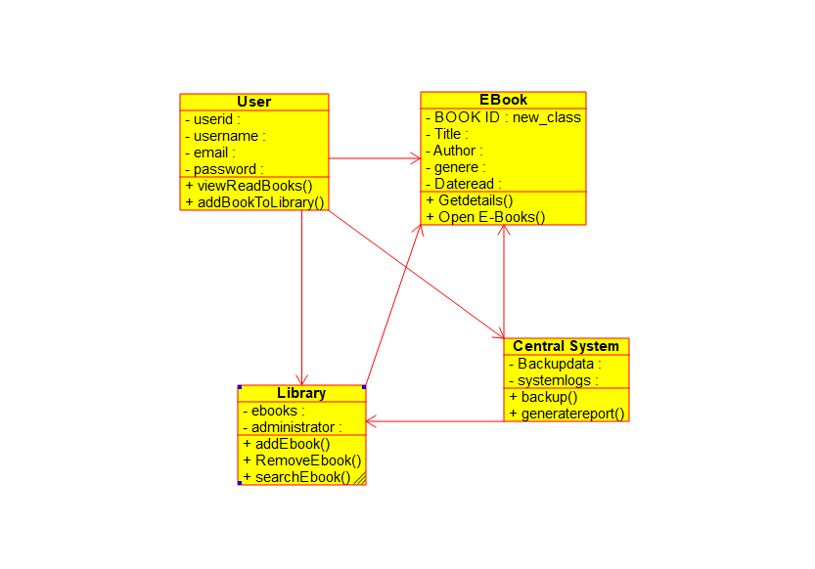

3.ACTIVITY DIAGRAM:-

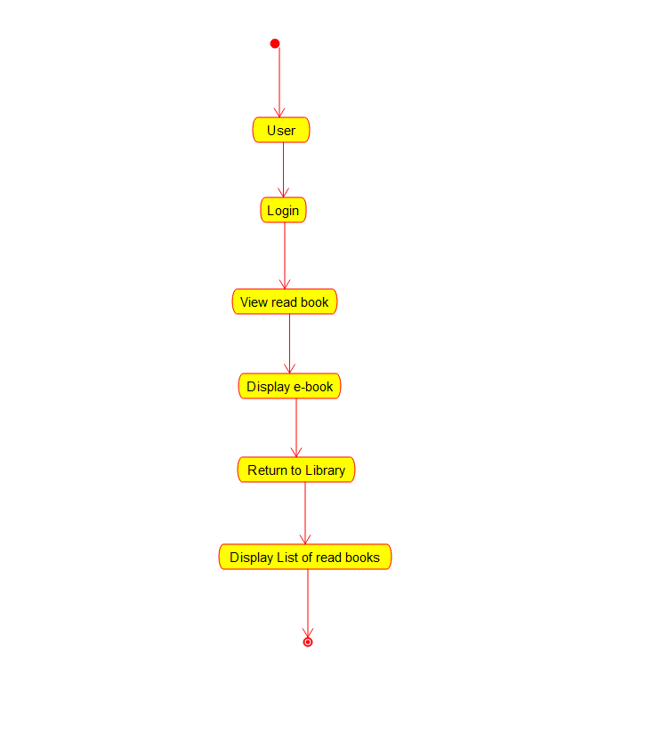

***10.AIM:-***To implement UML diagrams for SYSTEM…

***DESIGN:-***

1.PAKAGE DIAGRAM:-

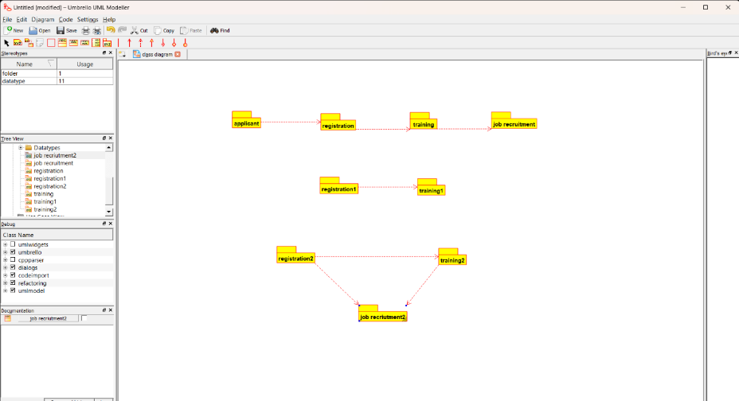

2.DEPLOYMENT DIAGRAM:-

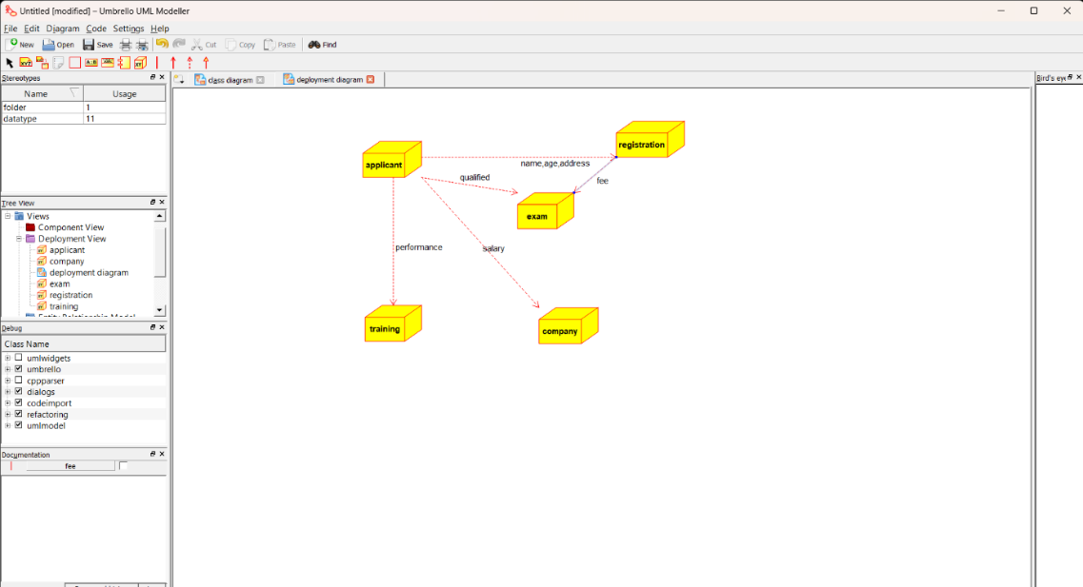

***3.COMPONENT DIAGRAM:-***

